**CS 200: Computer Organization**

**Project 4: Float Analysis**

Shariq M. Jamil

Due: Wednesday, March 5, 2014

**Overview**

**Purpose**

This project required us to write a program in C or C++ that accepts a floating point number and displays a bit-level representation of the number.

**Approach**

In order to complete this project I decided to break the project into small sections and wrote pseudocode for each part. After that, I went through the sections and used Google heavily to convert each section of pseudocode to C code. The first step was to accept the floating point number from the user followed by conversion to binary. Once I got this part working, I added code to prompt the user for input and created arrays to store the binary representation of the number. To get the binary representation of the float I used code found on a stackoverflow.com post. The post is linked in the comments within the code. After that, I followed the suggestions provided in the guide and performed bit-wise operations to extract the sign, exponent and significand from the binary representation. I commented my code heavily so that my step-by-step process is clear. The alternative representation gave me some trouble but I figured it after rereading the suggestions in the project guide and web searching.

**Solution**

**Sample Output**

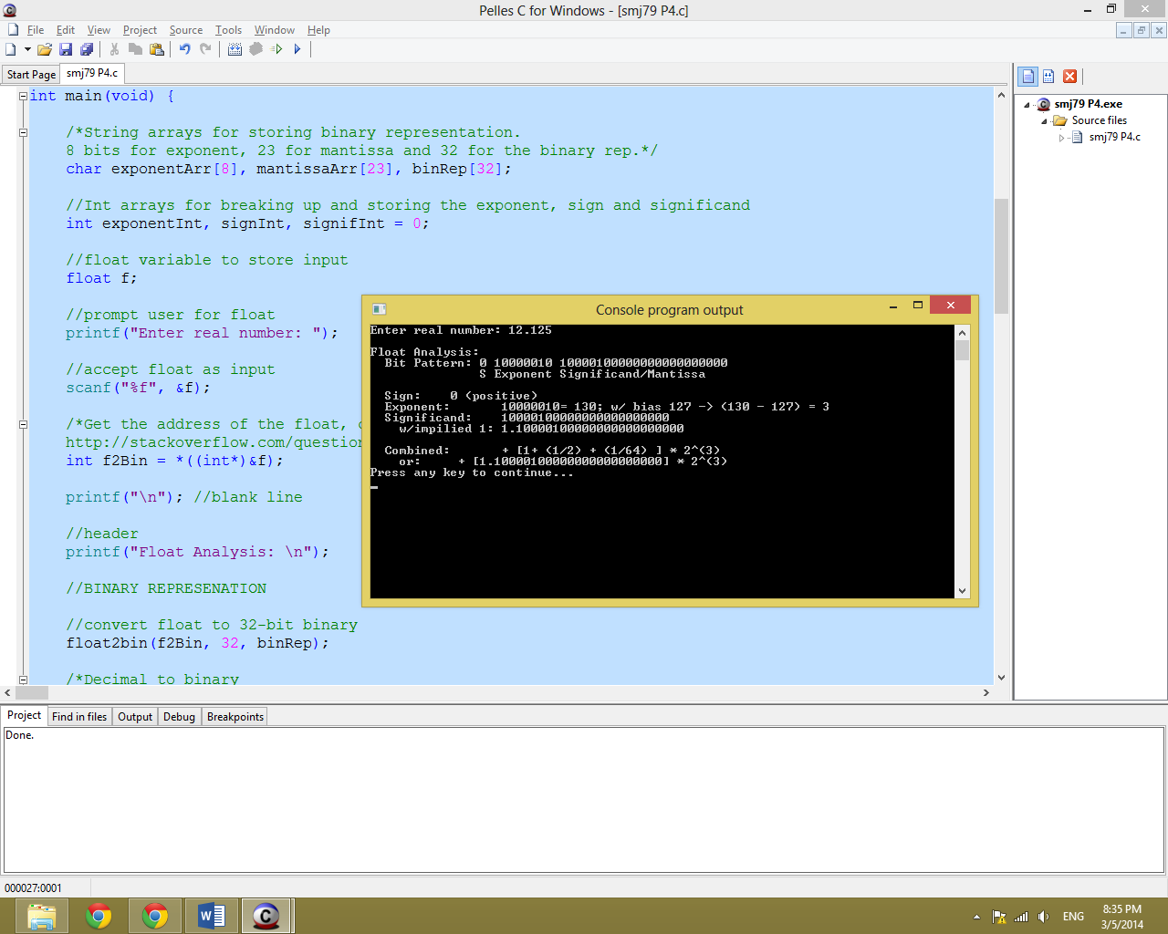

Output for 12.125

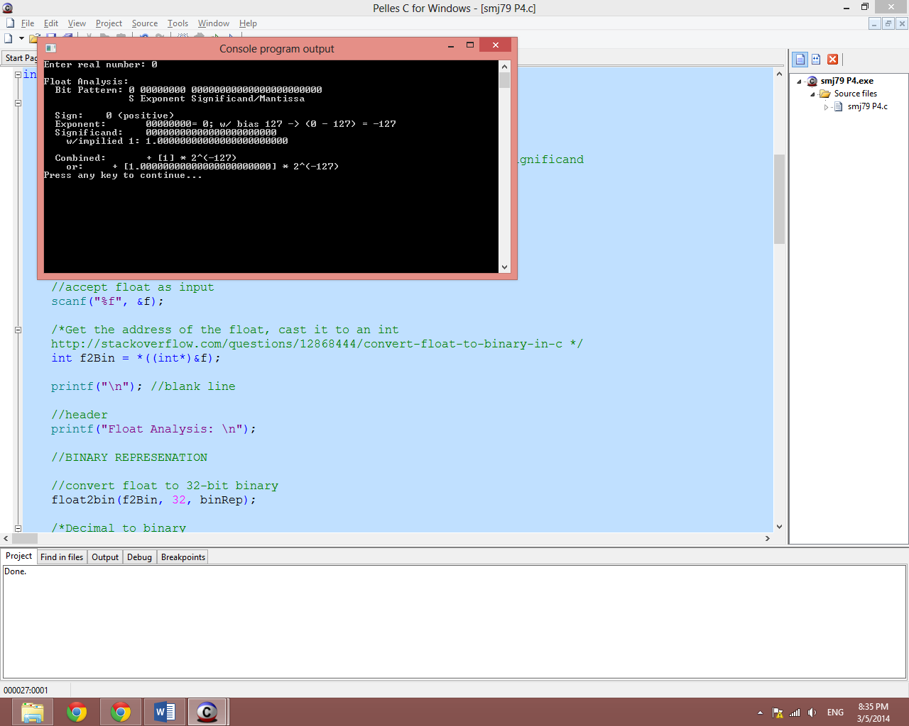

Figure 2: Output for 0

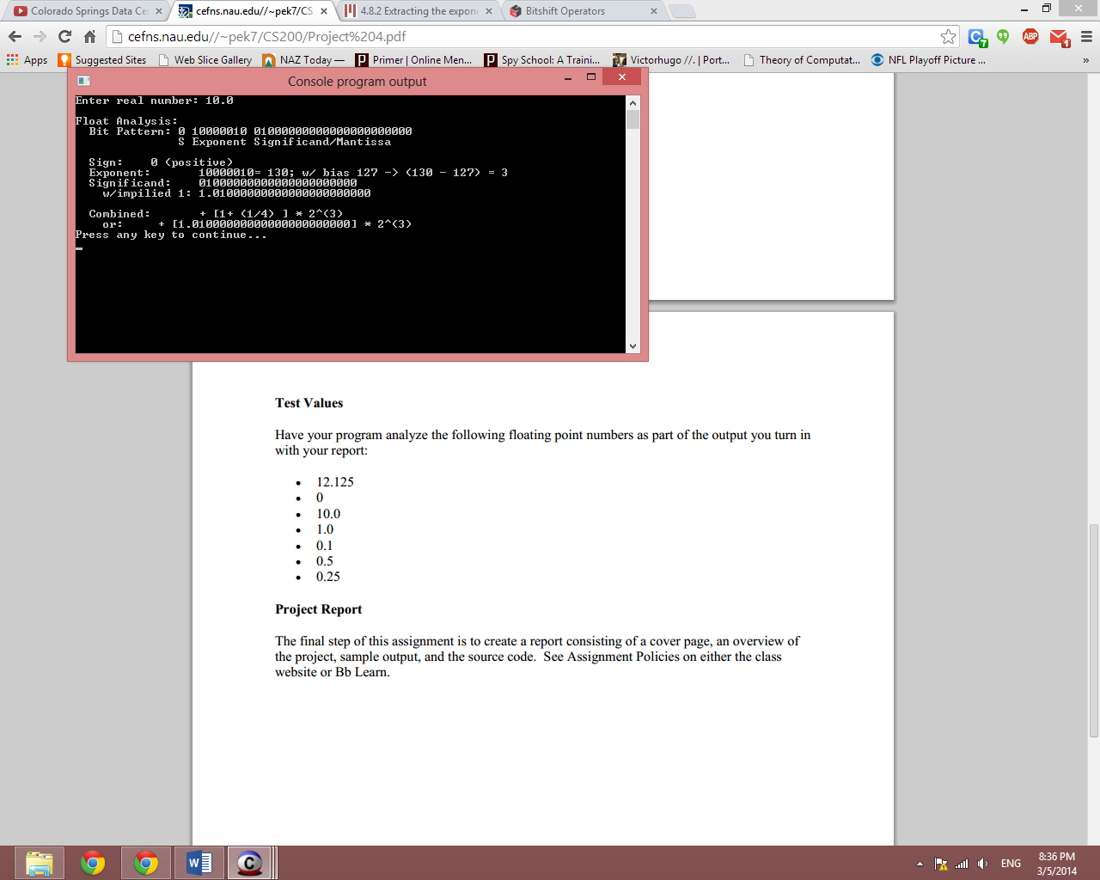

Figure 3: Output for 10.0

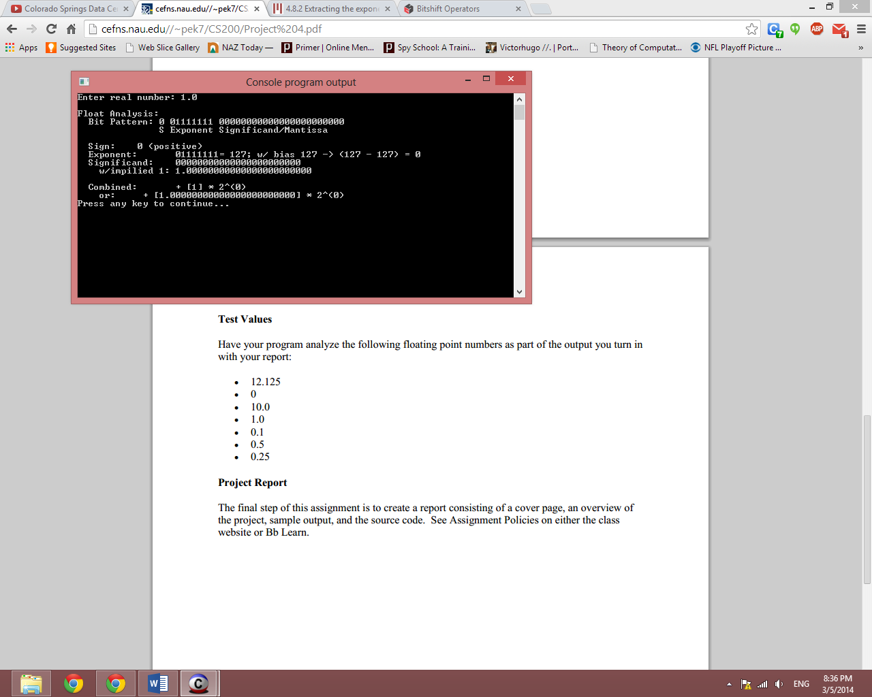

Figure 4: Output for 1.0

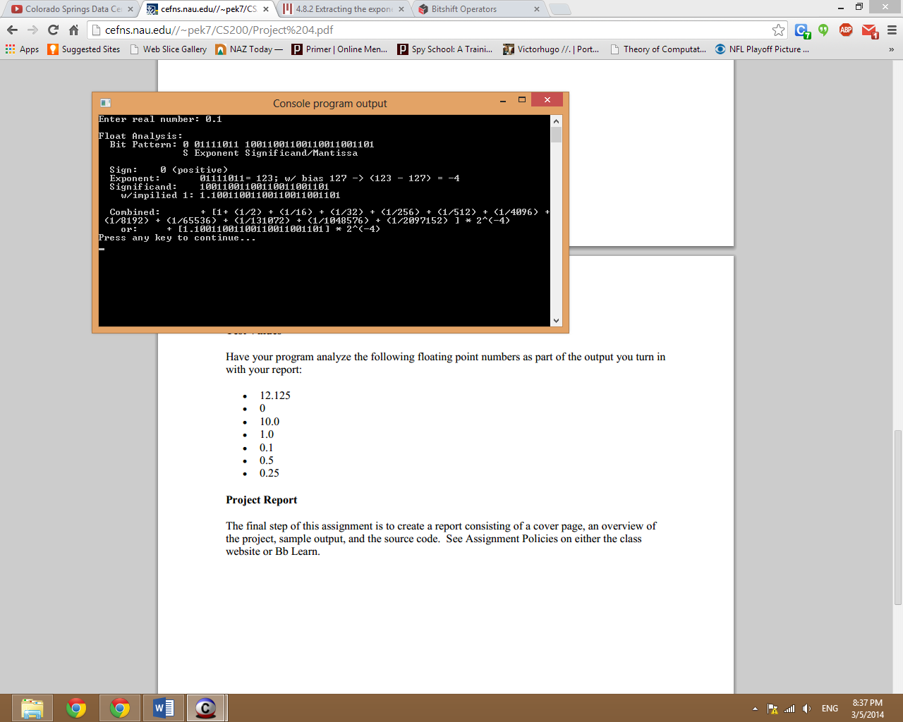

Figure 5: Output for 0.1

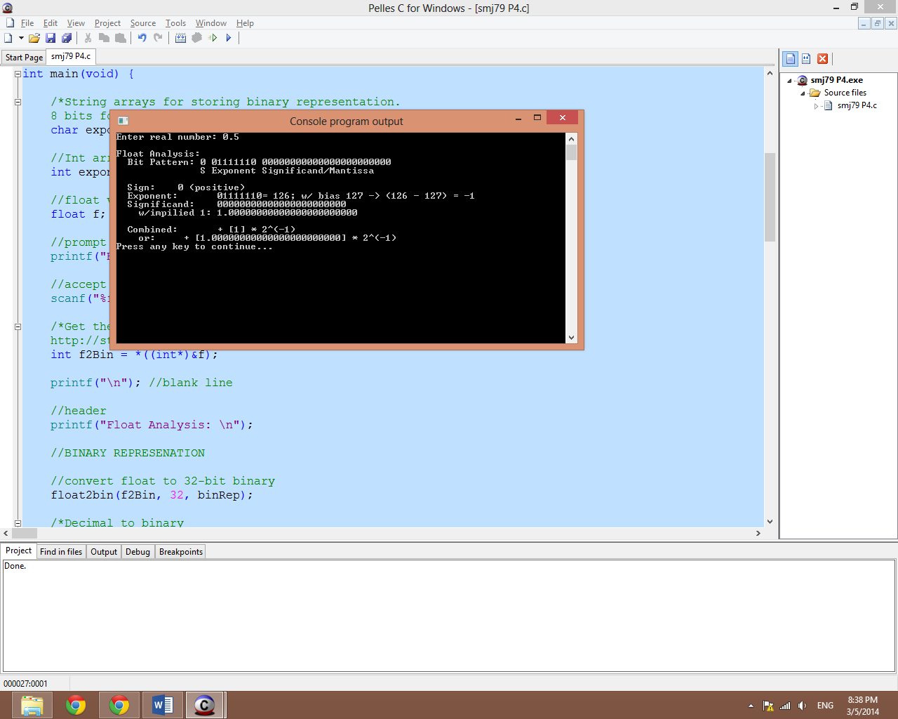

Figure 6: Output for 0.5

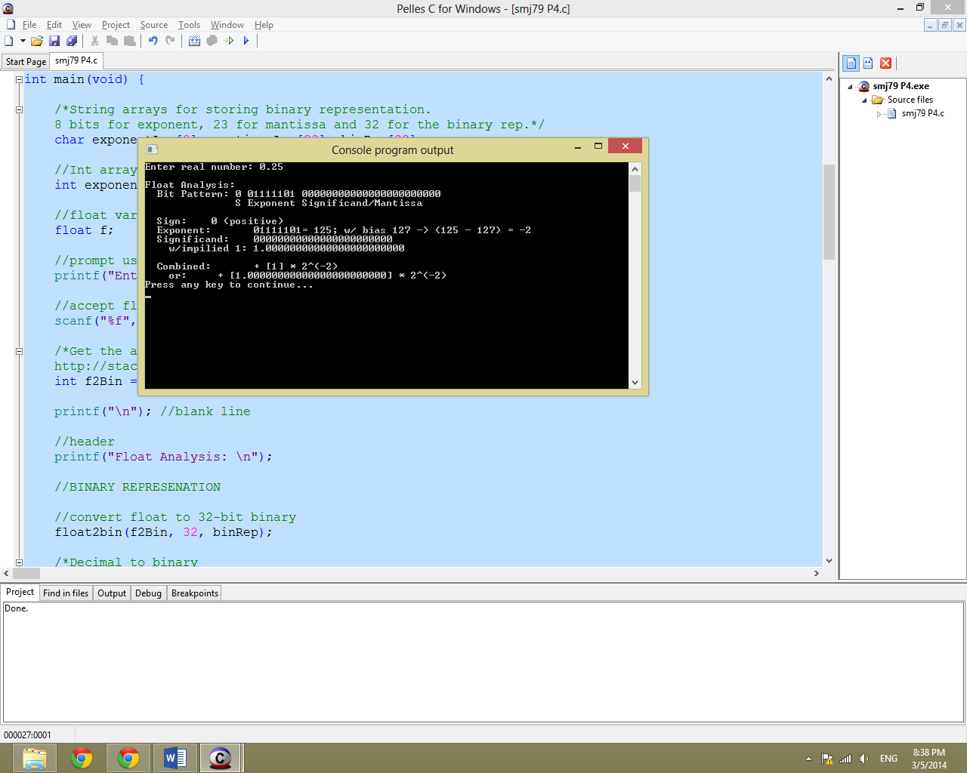

Figure 7: Output for 0.25

**Conclusion**

This project took me a while because this was my first time programming in C. It was a great experience to learn and implement a project using a language I had never touched before. I realize that I was not required to format my output to look like the output in the project guide but it was the easiest way for me to code the project having the final picture in mind. Without having the sample output, it would have been very difficult for me to provide the results this project required. The suggestions provided in the lab guide were very helpful as well and I would have been lost without them. This project pushed me to seek knowledge online which is great because trains me to learn independently.

This project solidified my bitwise operations and binary representation knowledge. The experience has inspired me to learn more about binary/assembly code and the role it plays in computation today. Overall, this was a great exercise being able to see my binary representations be confirmed by Wolfram Alpha was a fulfilling experience.

**References**

References not mentioned in the code are:

BitShift Operators

http://www.cs.umd.edu/class/sum2003/cmsc311/Notes/BitOp/bitshift.html

Extracting the exponent from the binary representation

http://web.mit.edu/hyperbook/Patrikalakis-Maekawa-Cho/node48.html

Stackoverflow - Floating-point: “The leading 1 is 'implicit' in the significand.” — …huh?

http://stackoverflow.com/questions/4930269/floating-point-the-leading-1-is-implicit-in-the-significand-huh